Design a Smart Parking Prediction System using Machine Learning
1. Problem Statement and SDG Identification
Problem Statement
Finding a vacant parking space in busy cities is a major challenge. Drivers often spend several minutes searching for parking, leading to traffic congestion, increased fuel consumption, air pollution, and wasted time. Existing parking systems usually display only the current availability of parking spaces without predicting future occupancy. A Machine Learning-based Smart Parking Prediction System can analyze historical parking data and predict future parking availability, enabling drivers to locate parking spaces quickly and efficiently.
Sustainable Development Goal (SDG)
SDG 11 – Sustainable Cities and Communities
Objective
Develop a smart parking prediction system that uses Machine Learning to forecast parking space availability, reducing congestion, fuel consumption, and carbon emissions while improving urban transportation efficiency.
2. Background Study
Urbanization has significantly increased the number of vehicles on roads, resulting in parking shortages. Research shows that a considerable amount of city traffic is caused by drivers searching for parking spaces. Traditional parking systems rely on manual monitoring or simple occupancy sensors that only indicate current status.
Machine Learning enables parking systems to learn from historical data and predict parking availability based on factors such as time, day, weather, holidays, and occupancy trends.
Machine Learning Challenges
- Data collection from parking sensors
- Missing or noisy sensor data
- Changing traffic patterns
- Peak-hour demand prediction
- Real-time prediction accuracy
- Large-scale data processing
3. Learning Problem
Type of Learning
Supervised Learning (Classification)
The system learns from historical parking data where the availability of parking spaces is already known.
Input Features
- Time of day
- Day of week
- Date
- Weather condition
- Parking location
- Number of occupied spaces
- Number of available spaces
- Public holiday (Yes/No)
- Special events nearby
Target Output
Parking Availability
- Available
- Limited
- Full
Data Representation
Time | Day | Weather | Occupied Spaces | Available Spaces | Holiday | Output
9 AM | Monday | Sunny | 70 | 30 | No | Available
2 PM | Saturday | Sunny | 95 | 5 | No | Full
6 PM | Friday | Rainy | 88 | 12 | No | Limited
10 AM | Sunday | Cloudy | 40 | 60 | No | Available

4. Selection of Machine Learning Approach
Selected Approach
Decision Tree Learning
Justification
Decision Tree is selected because:
- Easy to understand
- Fast prediction
- Suitable for classification problems
- Handles numerical and categorical data
- Provides clear decision rules
- Easy to implement
The Decision Tree predicts parking availability by splitting data based on different conditions like time, occupancy, and weather.
5. Proposed Algorithm and Workflow
Algorithm
Decision Tree Learning
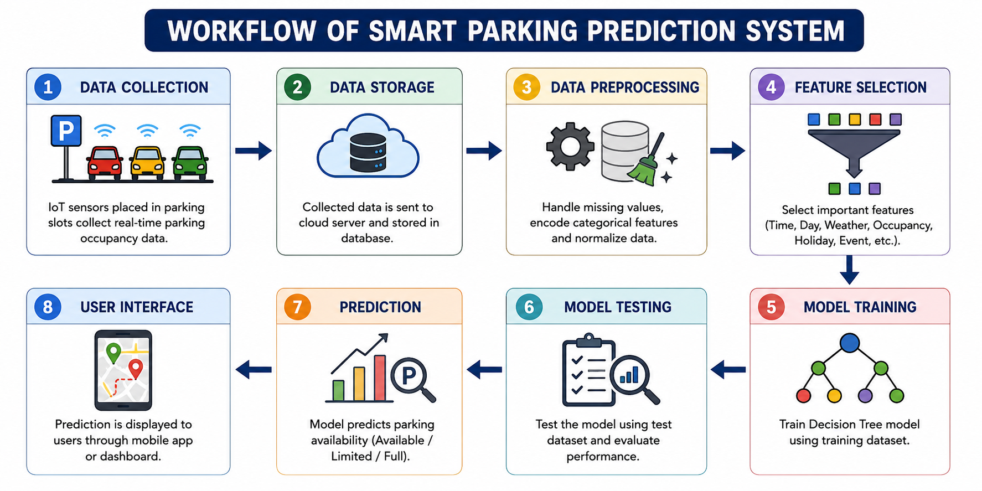
Workflow

Decision-Making Process 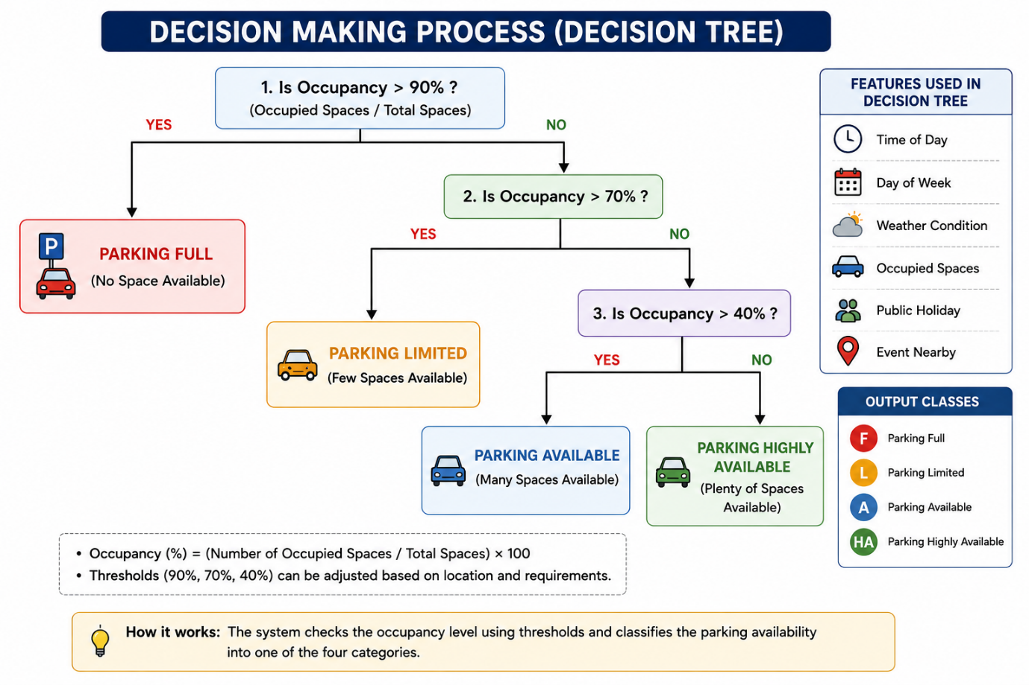
Parking Data
│
Is Occupancy > 90%?
/ \
Yes No
│ │
Parking Full Is Occupancy >70%?
/ \
Yes No
│ │
Limited Available

6. Expected Outcomes
- Predict parking availability before arrival
- Reduce vehicle searching time
- Decrease traffic congestion
- Lower fuel consumption
- Reduce carbon emissions
- Improve parking management
- Better utilization of parking spaces

7. Advantages
- Saves time
- Reduces fuel consumption
- Lowers air pollution
- Improves traffic flow
- Supports Smart City initiatives
- Easy to expand to multiple parking locations
- Real-time prediction capability
8. Limitations
- Requires historical parking data
- Sensor failure may affect predictions
- Weather changes can reduce accuracy
- Initial installation cost is high
- Requires continuous internet connectivity
9. Practical Applications
- Shopping malls
- Hospitals
- Airports
- Railway stations
- Universities
- Smart cities
- IT parks
- Commercial complexes
- Event venues
10. Recommendations
To improve the proposed Smart Parking Prediction System:
- Install IoT sensors for accurate occupancy detection.
- Use cloud storage for collecting historical parking data.
- Retrain the Decision Tree model regularly with new data.
- Integrate a mobile application to provide real-time parking predictions.
- Enable advance parking reservation based on predicted availability.
- Combine parking prediction with GPS navigation for optimal routing.
- Expand the system across multiple parking facilities to support smart city infrastructure.
These recommendations support SDG 11 (Sustainable Cities and Communities) by improving urban mobility, reducing congestion, and lowering environmental impact.
11. Conclusion
The proposed Smart Parking Prediction System uses Machine Learning to forecast parking availability based on historical parking data. A Decision Tree algorithm is selected due to its simplicity, interpretability, and effectiveness in classification tasks. The system helps drivers locate parking spaces quickly, reducing traffic congestion, fuel consumption, travel time, and carbon emissions. This solution contributes directly to SDG 11: Sustainable Cities and Communities by promoting efficient urban transportation and sustainable city development.
12. References
- Tom M. Mitchell, Machine Learning, McGraw-Hill Education, 1997.
- Ethem Alpaydin, Introduction to Machine Learning, MIT Press.
- Ian H. Witten, Eibe Frank, and Mark A. Hall, Data Mining: Practical Machine Learning Tools and Techniques, Morgan Kaufmann.
- United Nations Sustainable Development Goals (SDG 11): https://sdgs.un.org/goals/goal11
- UCI Machine Learning Repository: https://archive.ics.uci.edu/
- Kaggle Datasets: https://www.kaggle.com/datasets

